A000-CAN-NW Coast-Stone Bowl-Miocene **Basalt mortar with face of Tsagaglalal-pre 1800**

2

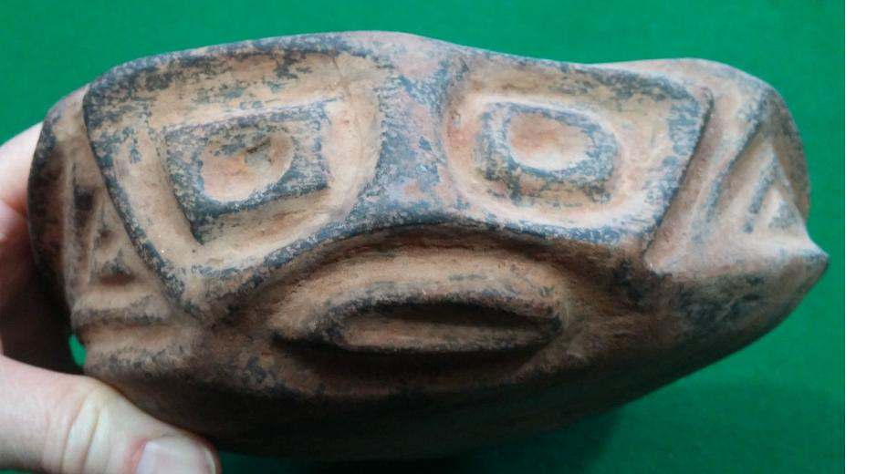

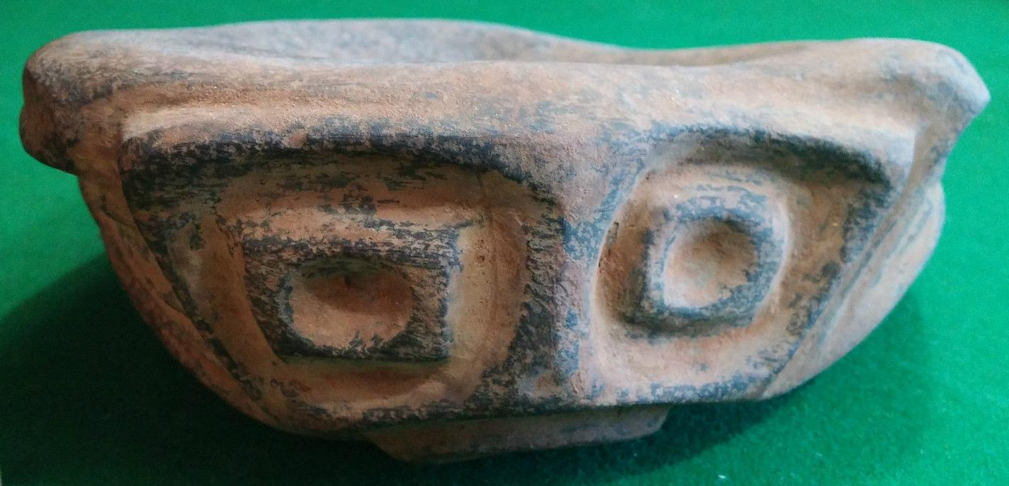

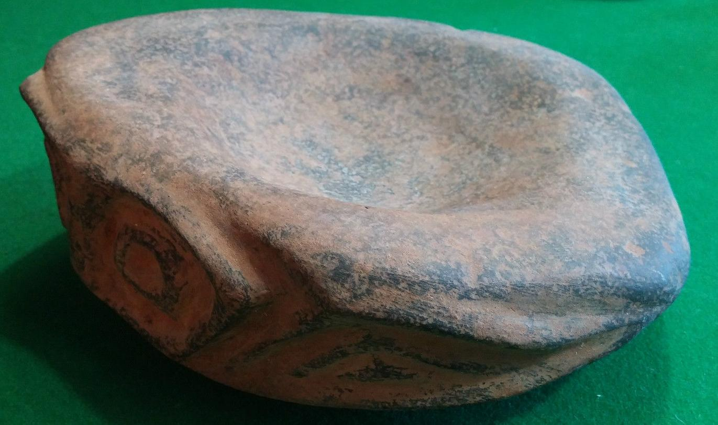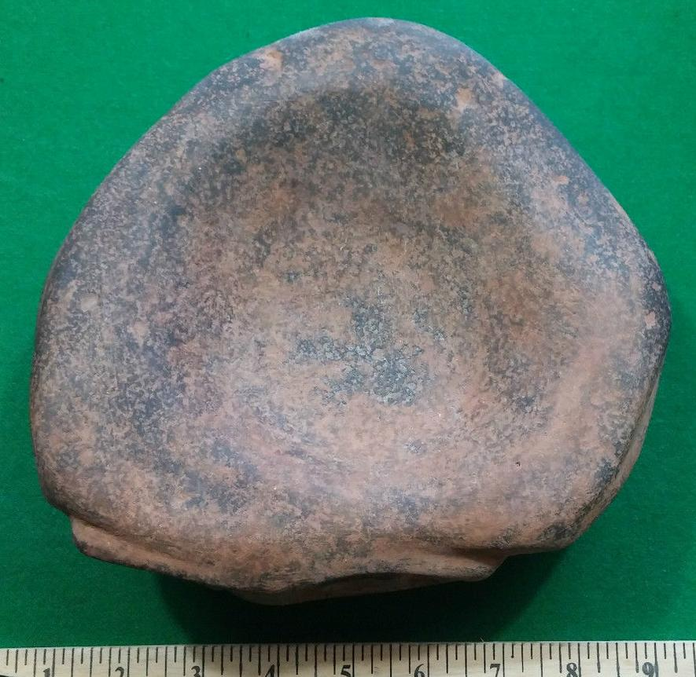

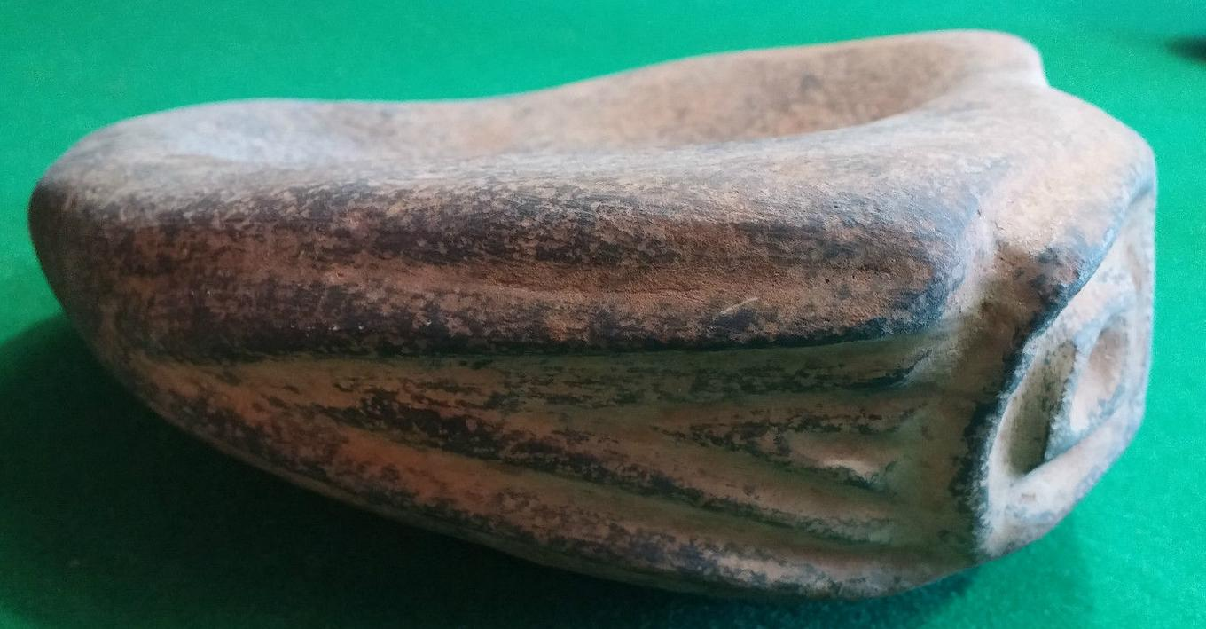

## Fig. 1-5: Miocene Basalt (Columbia River Basalt Group) mortar with face of **Tsagaglalal -- "She Who Watches."**

## 

## Fig. 6-7. Edward S. Curtis, **Tsagaglalal Petroglyph -- "She Who Watches"** petroglyph, on Miocene basalt from Columbia Hills State Park - Horsethief Lake Petroglyphs, Eastern Gorge, Washington. Left, sepia, right gray scale.

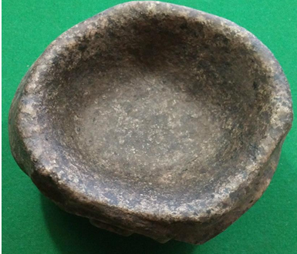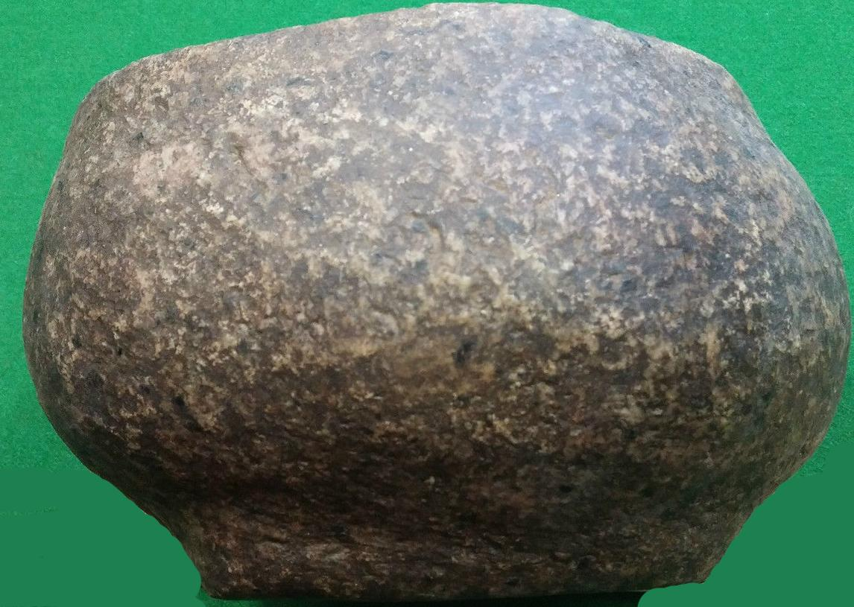

Formal Label: Miocene **Basalt (Columbia River Basalt Group**) **mortar with face of Tsagaglalal-pre 1800**

Accession Number:

LC Classification:

Date or Time Horizon: pre-1800

Geographical Area: Columbia River, near Horsethief Lake, at a place the Wishram call“*timm*” (The Journals of Lewis and Clark, **Clark, October 24, 1805.**

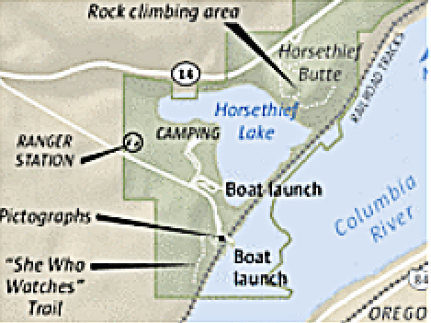

Mark Nowlin, The Seattle Times, http://old.seattletimes.com/ABPub/2013/05/15/2020993143.gif

Cultural Affiliation: Wishram (?).

Medium: Miocene Basalt, Columbia River Basalt Group (CRBG), 17 and 12 Ma

Dimensions: Weight:

Provenance: Wishram (?).

**Condition: No defects**

**Discussion: from the area of the Dalles (**French [*dalle*](https://en.wiktionary.org/wiki/dalle) “slab”) (Gibson 1997: 125; Mc Arthur and McArthur 1996: 826). referring to the Miocene columnar basalt rocks on the Columbia River created by the cooling of a thick lava flow, in which columns formed as a random cellular network, that are predominantly hexagonal in cross-section *(*Weaire and Rivier 2006).

1. The legend of Tsagaglalal. From Pitt 2016.

"There was this [Wishram] village on the Washington side of the Columbia Gorge. And this was long ago when people were not yet real people, and that is when we could talk to the animals.

And so Coyote — the Trickster — came down the river to the village and asked the people if they were living well. And they said "Yes, we are, but you need to talk to our chief, **Tsagaglalal**. She lives up in the hill."

So Coyote pranced up the hill and asked **Tsagaglalal** if she was a good chief or one of those evildoers. She said, "No, my people live well. We have lots of salmon, venison, berries, roots, good houses. Why do you ask?" And Coyote said, "Changes are going to happen. How will you watch over your people?" And so she didn't know.

And it was at that time that Coyote changed her into a rock to watch her people forever."

1. The legend of Tsagaglalal. From Saynich 2015.

A woman was chief of all who lived in this region. That was a long time before Coyote came up the river and changed things, and the people were not yet real people. After a time, Coyote, in his travels came to this place and asked the inhabitants if they were living well or ill. They sent him to their chief who lived up in the rocks, where she could look down on the village and know what was going on.

Coyote climbed up to the house on the rocks and asked, “What kind of living do you give these people? Do you treat them well or are you one of those evil women?”

“I am teaching them to live well and build good houses,” she said.

When she expressed her desire to be able to do this forever, he said, “Soon the world will change and women will no longer be chiefs.”

Being the trickster that he was, Coyote changed her into a rock with the command, “You shall stay here and watch over the people and the river forever.”

1. **Moulton 1983: 331-332. [Clark] October 24th Thursday 1805.**

The whole of the Current of this great river must at all Stages pass thro' this narrow chanel of 45 yards wide. as the portage of our canoes over this high rock would be impossible with our Strength, and the only danger in passing thro those narrows was the whorls and Swills arriseing from the Compression of the water, and which I thought (as also our principal watermen Peter Crusat) by good Stearing we could pass down Safe, accordingly I deturmined to pass through this place notwithstanding the horrid appearance of this agitated gut Swelling, boiling & whorling in every direction (which from the top of the rock did not appear as bad as when I was in it;) however we passed Safe to the astonishment of all the Inds: of the last Lodges who viewed us from the top of the rock [this high rock became Browns Island when the waters of Lake Celilo inundated the valley]. passed one Lodge below this rock and halted on the Star[boa]d. Side to view a verry bad place, the Current divided by 2 Islands of rocks the lower of them large and in the middle of the river, this place being verry bad I Sent by land all the men who could not Swim and Such articles as was most valuable to us Such as papers Guns & amunition, and **proceeded down with the Canoes two at a time to a [Wishram] village of 20 wood housies in a Deep bend to the Star[boar]d. Side [area of Horsethief Butte and Horsethief Lake] below which a rugid black rock about <the> 20 feet hiter <of> than the Common high fluds of the river with Several dry Chanels which appeared to Choke the river up quite across; this I took to be the 2d falls or the place the nativs above call *timm*,** The nativs of this village re[ce]ived me verry kindly, one of whome envited me into his house, **...**    I dispatched a Sufficent number of the good Swimers back for the 2 canoes above the last rapid and with 2 men walked down three miles to examine the river Over a bed of rocks, which the water at verry high fluds passes over, on those rocks I Saw Several large Scaffols on which the Indians dry fish; as this is out of Season the poles on which they dry those fish are tied up verry Securely in large bundles and put upon the Scaffolds, I counted 107 <Scaff> Stacks of dried pounded fish in different places on those rocks which must have contained 10,000 w. of neet fish,

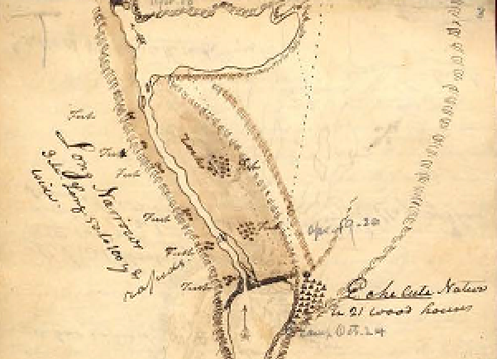

Map of the Wishram village of “21 wood houses” Codex H, No. 2, p. 3, “A Sketch of the Long & Short, Narrows of the Columbia River,” Oct. 22-28, 1805, by Captain James Clark, American Philosophical Society, graphics 2628.

1. **Petroglyphs**

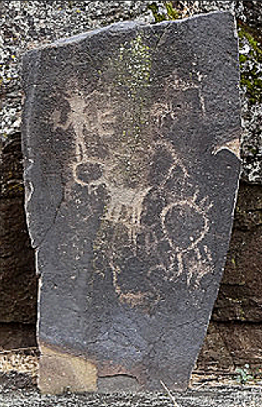 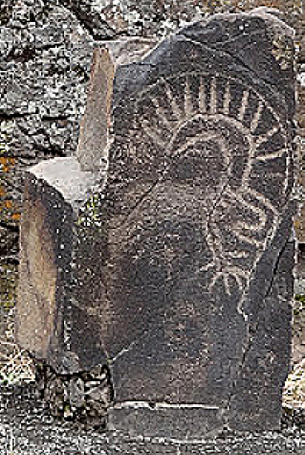

From <http://columbiariverimages.com/Images11/horsethief_lake_park_petroglyphs_10-15-11.jpg>

These petroglyph panels on Miocene basalt are palimpsests with older petroglyphs effaced beneath much newer ones. The one on the left may recount (in a newer petroglyph) the myth of coyote (four-legged animal) making Tsagaglalal (anthropomorph with both hands akimbo) into a petroglyph.

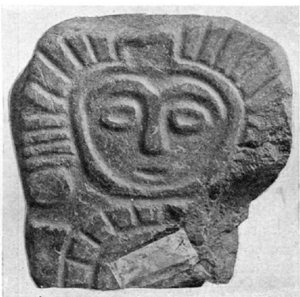

1. **Stone statuette from near** Lyle, Washington. courtesy of B. C. Markham.
2. **Geology**

"Flood basalts of the Miocene Columbia River Basalt Group (CRBG) are among the most voluminous and far-traveled lava flows on earth. About 10% of the basalt flows that erupted on the Columbia Plateau between 17 and 12 Ma were voluminous enough to pass through the Cascade arc via a wide ancestral Columbia River valley, and some of them eventually reached the Pacific Ocean” (Wells, Niem, Evarts, and Hagstrum 2009).

**References:**

Boas, Franz. 1893. *"Doctrine of Soul and Disease Among the Chinook."* JAFL 6:39-43.

Boas, Franz. 1894. *Chinook* *Texts*. Bureau of American Ethnology Bulletin 20. Washington, D.C.

Boas, Franz. 1901. *Kathlamet Texts*. Bureau American of Ethnology Bulletin 26. Washington, D.C.

Boas, Franz. 1933. "Notes on the Chinook Jargon," *Language* 9:208-13.

Cressman, Luther S. 1960. *Cultural Sequences at The Dalles, Oregon. Philadelphia: American Philosophical Society*.

Curtis, Edward. 1910. *The North American Indian*. 8:85-154, 172-83, 198-205.

French, David.1961. *"Wasco-Wishram."* In *Perspectives in American Indian Cultural Change*, ed. Edward H. Spicer. 337-430. Chicago: Univ. of Chicago Press.

Gibbs, George. 1955-6. "Account of Indian Mythology of Oregon and Washington Territory," *Oregon Historical Quarterly*, 56:293-325, 57:125-67.

Gibson, James R. (1997). The Lifeline of the Oregon Country: The Fraser-Columbia Brigade System, 1811–47. University of British Columbia (UBC) Press. p. 125.

Jacobs, Melville. 1955. "A Few Observations on the World View of Clackamas Chinook Indians." Journal of American Folklore, 68:283-89.

Jacobs, Melville 1958. *Clackamas Chinook Texts*. Bloomington: Univ. of Indiana.

Kane, Paul. 1971. *Paul Kane's Frontier*. Austin, Texas: ed. J. Russell Harper. -------1971. *Columbia Wanderer.* Ed. Thomas Vaughan. OHSP.

McArthur, Lewis A.; McArthur, Lewis L. (1992) [1928]. Oregon Geographic Names (6th ed.). Portland, Oregon: Oregon Historical Society Press. p. 826.

Moulton, Gary E. 1983. *The Journals of Lewis and Clark*. Lincoln and London: University of Nebaska Press, pp. 331-32. [Clark] October 24th Thursday 1805.

Pitt, Lillain. 2016. Pacific Northwest Native American Artist, "lillianpitt.com" website.

Rubin, Rick. 1981. *"Coyote on the Columbia."* In The Northwest Experience 2:166-79. Seattle: Madrona Publishers.

--1986. *"She Who Watches."* Portland: Northwest Magazine, (Sept. 28).

--1999. *Naked Against the Rain: The People of the Lower Columbia River.* Portland: Far Shore Press.

Sapir, Edward. 1909. *Wishram Texts.* American Ethnological Society.

Sapir, Edward and Spier, Leslie. 1930. *Wishram Ethnography*. Seattle: Univ. of Washington.

# Saynich, Carol. 2015. “The Legend Of Tsagaglalal (She Who Watches).”

Silverstein, Michael. 1990. *"Chinookans of the Lower Columbia."* In Handbook of North American Indians, 7:533-46.

Smith, Marian W. 1943. *"Columbia Valley Art Style."* American Antiquity (ns) 45:158-60.

Smith, Marian W. 1949. *"Basketry Design and the Columbia Valley Art Style."* South Western Journal of Archeology 8:336ff.

Strong, W. Duncan. 1945. *The Occurrence and Wider Implications of a 'Ghost Cult' on the Columbia River Suggested by Carvings in Wood, Bone and Stone."*" American Antiquity 47:244-261.

Strong, W. Duncan, Schenck AND Julian Steward 1930 Archaeology of the Dalles-Deschutes Region. University of California Publications, American Archaeology and Ethnology 29: No

Steward, Julian 1927 A New Type of Carving from the Columbia Valley. American Anthropologist, n.s., 29: No. 2, 255-261.

Weaire, D. and N. Rivier. 2006. "Soap, cells and statistics—random patterns in two dimensions," Contemporary Physics, **25** (1): 59–99.

Wells, R.E., Niem, A.R., Evarts, R.C., and Hagstrum, J.T., 2009, "The Columbia River Basalt Group -- From the gorge to the sea", IN: Jim E. O’Connor, Rebecca J. Dorsey and Ian P. Madin, eds., *Volcanoes to Vineyards: Geologic Field Trips through the Dynamic Landscape of the Pacific Northwest*, Geologic Society of America Field Guide, 15, pp.737-774.